FOR IMMEDIATE RELEASE
Jan. 28, 2026
With Just Three Days Before the Jan. 31 Deadline to Sign Up for Health Insurance, Covered California Urges All Uninsured Californians to Act Now

SACRAMENTO, Calif. — Covered California is urging all Californians to act now to sign up for or renew their health insurance in 2026. Consumers can compare health insurance options to find a plan that meets their needs and budget.
As the Jan. 31 open-enrollment deadline quickly approaches, Covered California has helped more than 1.9 million Californians access the high-quality health insurance they need to keep themselves and their families healthy this year. More than 385,000 Californians have enrolled in a 2026 plan with a monthly premium of $10 or less per member.
Those without insurance still have time to use the Shop and Compare Tool on CoveredCA.com to compare options and sign up for coverage that begins on Feb. 1.
This open enrollment, more than 200,000 Californians have signed up for new health insurance in 2026 as of Jan. 24, despite the expiration of the federal Enhanced Premium Tax Credits that have helped millions of Americans access health insurance.
Additionally, 1.7 million Californians have renewed their health insurance plans, a 4 percent jump over the same date last year, despite the decision by Congress to not extend the Enhanced Premium Tax Credits that lowered monthly premiums for millions of Americans, which led to record enrollment in 2025.
“Although Congress did not extend the financial assistance that has helped millions of Americans afford health insurance, thousands of families across California are showing how critical having coverage is to them,” said Covered California Executive Director Jessica Altman. “We are proud of the work we’ve done to help connect Californians to care, but we have a long way to go. As we approach the final deadline for open enrollment, we’re encouraging everyone to explore their options and find a plan that helps protect the physical, mental and financial health of you and your family.”
Once open enrollment ends on Friday, Californians will need to have experienced a major life change to enroll in health insurance through Covered California. So now is the time to sign up, whether it’s on CoveredCA.com or through one of the 14,000 Licensed Insurance Agents or community partners available that provide free, confidential assistance.
Nearly half of the new enrollees come from Southern California, with more than 96,000 new sign-ups. Also, nearly 50,000 new enrollees statewide identified as Latino, and more than 40,000 identified as Asian American. More than 51,000 White Californians and more than 6,000 Black Californians have enrolled, while more than 37,000 Californians did not disclose their race or ethnicity.
Figure 1: More Than 200,000 Californians Have Signed Up During Open Enrollment Through Jan. 24
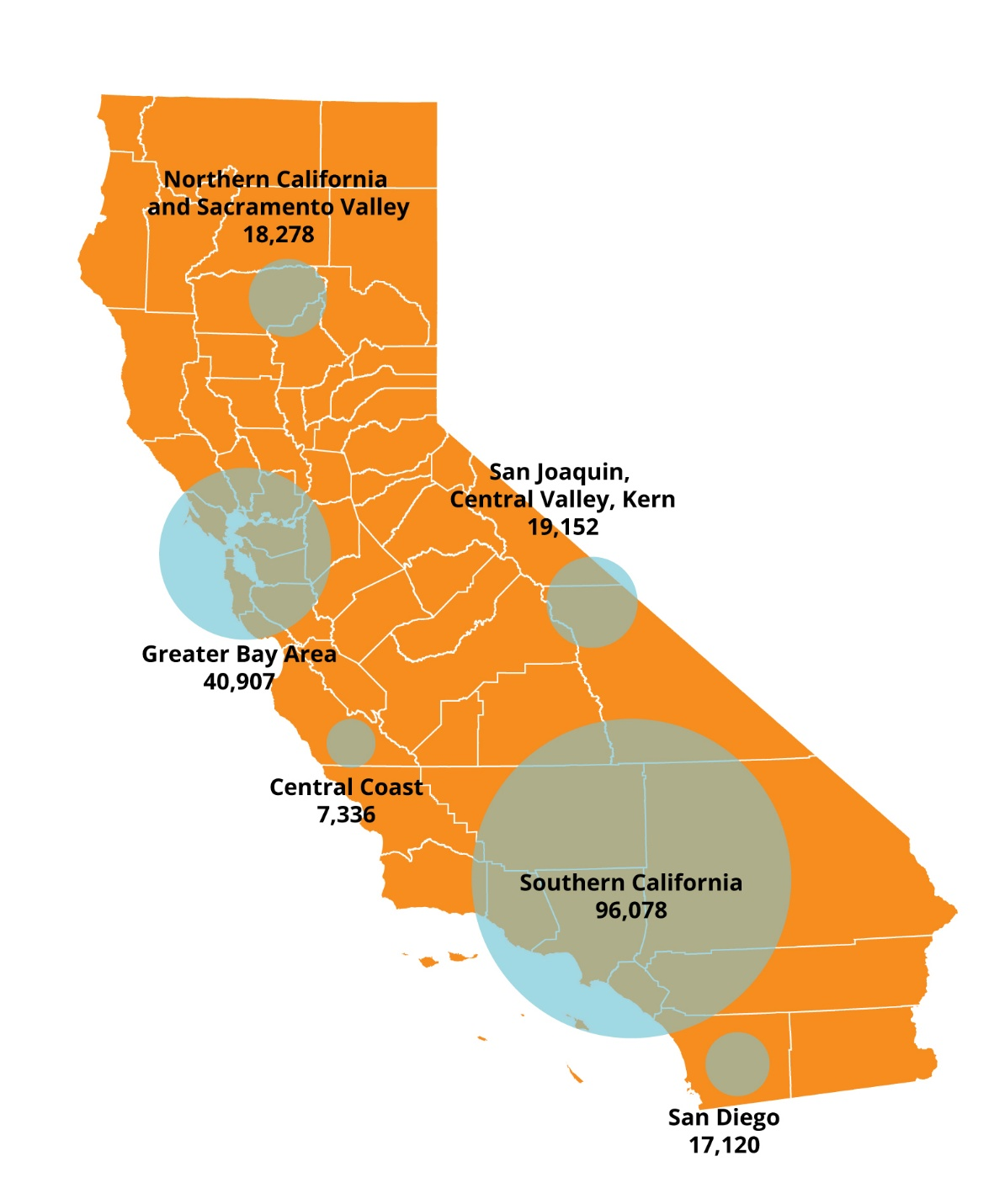
Data from the California Simulation of Insurance Markets (CalSIM), a model created by the UCLA Center for Health Policy Research, showed that heading into open enrollment, there were nearly 1.2 million Californians who either qualify for subsidies through Covered California (508,000) or low-cost or no-cost Medi-Cal (682,000) who remain uninsured and eligible for insurance in 2026.
Improving Affordability for California Families
In 2024 and 2025, Covered California implemented a cost-sharing reduction program that reduces the cost of accessing health care for consumers — by lowering out-of-pocket costs, such as deductibles, copays and coinsurance — who enroll in a health plan through Covered California.
Over the course of two program years, more than 1.9 million Californians benefited from the state’s enhanced cost-sharing reductions.
For 2026, the state of California has put $190 million toward keeping monthly premiums reasonable for the most vulnerable in the state. While this funding doesn’t make up for the $2.5 billion lost with Enhanced Premium Tax Credits sunsetting, nearly 400,000 enrollees are already benefiting. Thousands more across the state are switching to lower-cost plans that help keep their families covered at a price they can afford.
Approximately 82 percent of Covered California’s enrollees are eligible to receive financial help in 2026. Over half of enrollees are eligible for health insurance for $10 or less per month, and more than a quarter could get a comprehensive Silver plan for that price.
Signing Up for Coverage Is Easy
Consumers can learn more about their options by visiting CoveredCA.com, where they can easily find out if they qualify for financial help and see the coverage options in their area. Those interested in learning more about their coverage options can also:
- Get free and confidential assistance over the phone, in a variety of languages, from one of more than 14,000 certified agents and community-based organizations throughout the state that provide free, confidential help in whatever language or dialect consumers prefer.
- Have a certified enroller call them and help them for free.
- Use Covered California’s online calculator tool.
- Call Covered California at (800) 300-1506.
Californians who forgo health insurance will be subject to a tax penalty administered by the California Franchise Tax Board. The penalty for not having coverage the entire year will be at least $950 per adult and $450 per dependent child under 18 in the household. A family of four that goes uninsured for the whole year would face a penalty of at least $2,800.
About Covered California
Covered California is the state’s health insurance marketplace, where Californians can find affordable, high-quality insurance from top insurance companies. Covered California is the only place where individuals who qualify can get financial assistance on a sliding scale to reduce premium costs. Consumers can then compare health insurance plans and choose the plan that works best for their health needs and budget. Depending on their income, some consumers may qualify for the low-cost or no-cost Medi-Cal program.
Covered California is an independent part of the state government whose job is to make the health insurance marketplace work for California’s consumers. It is overseen by a five-member board appointed by the governor and the Legislature. For more information about Covered California, please visit www.CoveredCA.com.
###

